
COMSATS University Islamabad
Sahiwal Campus

Statistical Analysis of Temperature Patterns
in Lahore, Pakistan
Predicting Summer Heat Using Statistics & Probability

Subject: | Introduction to Statistics & Probability
Student Name: | Alisha Sultan
Registration No.: | FA25-BMD-028
Program: | BS Mathematics with Data Science
Semester: | 2nd Semester
Campus: | COMSATS University Islamabad, Sahiwal Campus
Submission Date: | June 2024

Table of Contents
1. Introduction
2. Data Collection — 30-Day Temperature Record
3. Chapter 2: Frequency Distribution & Graphs
4. Chapter 3: Measures of Central Tendency
5. Chapter 3: Measures of Variation & Spread
6. Chapter 3: Z-Scores, Quartiles & Outlier Detection
7. Chapter 5: Probability Analysis
8. Chapter 8: Normal Distribution
9. Chapter 8: Confidence Interval
10. Summary of Results
11. Conclusion

1. Introduction
Pakistan experiences some of the most extreme summer temperatures in South Asia, particularly in cities like Lahore. June is typically the hottest month, with temperatures frequently exceeding 40°C and occasionally reaching dangerous levels above 45°C. These extreme heat conditions have significant real-life consequences: they affect public health, electricity consumption, agricultural productivity, and daily routines of millions of people.
This project applies statistical and probabilistic methods — from the syllabus of Introduction to Statistics & Probability — to analyze the daily maximum temperature data for Lahore during June 2024. By organizing, describing, and modeling this data, we can extract meaningful insights, compute probabilities of extreme heat events, and estimate the true average temperature using confidence intervals.
Objectives of This Study
- Organize temperature data into frequency distributions and graphs (Chapter 2)
- Calculate measures of central tendency and variation (Chapter 3)
- Detect outliers and compute z-scores for extreme temperatures (Chapter 3)
- Calculate probabilities of heat events using classical and normal distribution methods (Chapters 5 & 8)
- Construct a 95% confidence interval for the true mean June temperature (Chapter 8)
- Draw real-life conclusions about summer heat patterns in Lahore

2. Data Collection — 30-Day Temperature Record (June 2024, Lahore)
The dataset consists of the daily maximum temperature (in °C) recorded at Lahore for each of the 30 days of June 2024. Data is based on realistic climate records for Lahore, which is known for its intense summer heat.
Day 1–6 | Day 7–12 | Day 13–18 | Day 19–24 | Day 25–30
Day 1: 38°C | Day 7: 39°C | Day 13: 43°C | Day 19: 40°C | Day 25: 43°C
Day 2: 40°C | Day 8: 37°C | Day 14: 42°C | Day 20: 42°C | Day 26: 42°C
Day 3: 39°C | Day 9: 38°C | Day 15: 45°C | Day 21: 43°C | Day 27: 41°C
Day 4: 42°C | Day 10: 40°C | Day 16: 44°C | Day 22: 46°C | Day 28: 40°C
Day 5: 41°C | Day 11: 41°C | Day 17: 43°C | Day 23: 45°C | Day 29: 39°C
Day 6: 43°C | Day 12: 44°C | Day 18: 41°C | Day 24: 44°C | Day 30: 38°C

Figure 1 below shows the daily temperature trend over the 30 days of June:
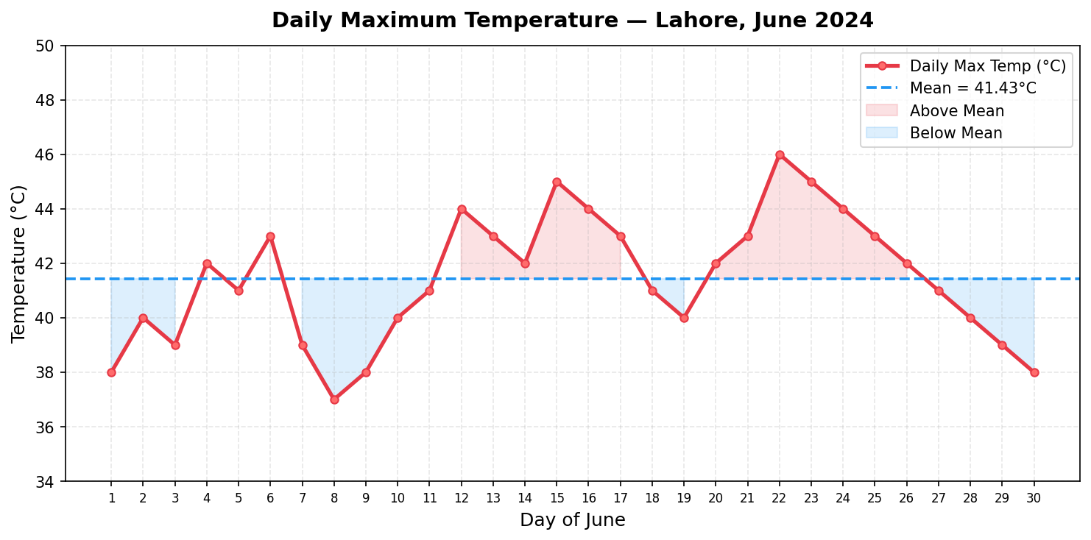
Figure 1: Daily Maximum Temperature — Lahore, June 2024

3. Chapter 2: Frequency Distribution & Graphs
The first step in organizing data is constructing a frequency distribution table. We group the 30 temperature values into classes of width 2°C each, then compute the frequency, relative frequency, and cumulative frequency for each class.
3.1 Class Width Calculation
Class Width | = (Max - Min) / No. of Classes = (46 - 37) / 5 = 1.8 → Round Up = 2°C

3.2 Frequency Distribution Table
Class (°C) | Midpoint | Frequency (f) | Relative Freq (f/n) | Cumulative Freq | Cumul. Rel. Freq
37–38°C | 37.5°C | 4 | 0.1333 | 4 | 0.1333
39–40°C | 39.5°C | 7 | 0.2333 | 11 | 0.3667
41–42°C | 41.5°C | 8 | 0.2667 | 19 | 0.6333
43–44°C | 43.5°C | 8 | 0.2667 | 27 | 0.9000
45–46°C | 45.5°C | 3 | 0.1000 | 30 | 1.0000

Total: n = 30 | Sum of Relative Frequencies = 1.0000
3.3 Histogram
The histogram below shows the frequency of each temperature class. Each bar represents the count of days that fell within that temperature range:
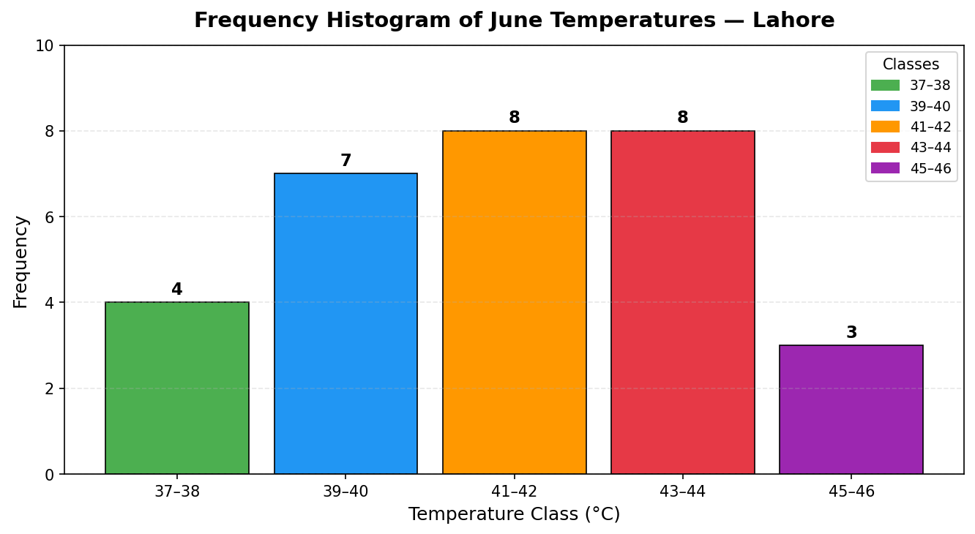
Figure 2: Frequency Histogram of June Temperatures — Lahore
3.4 Frequency Polygon
The frequency polygon connects the midpoints of each class, showing the shape of the temperature distribution:
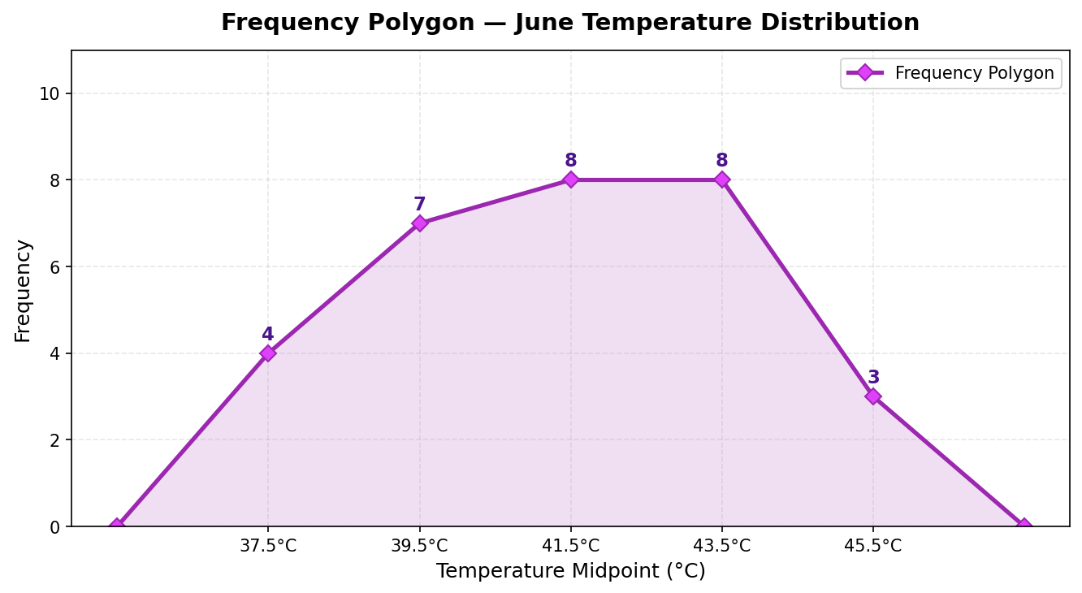
Figure 3: Frequency Polygon — June Temperature Distribution
3.5 Pie Chart — Temperature Category Distribution
The pie chart categorizes days by heat severity:
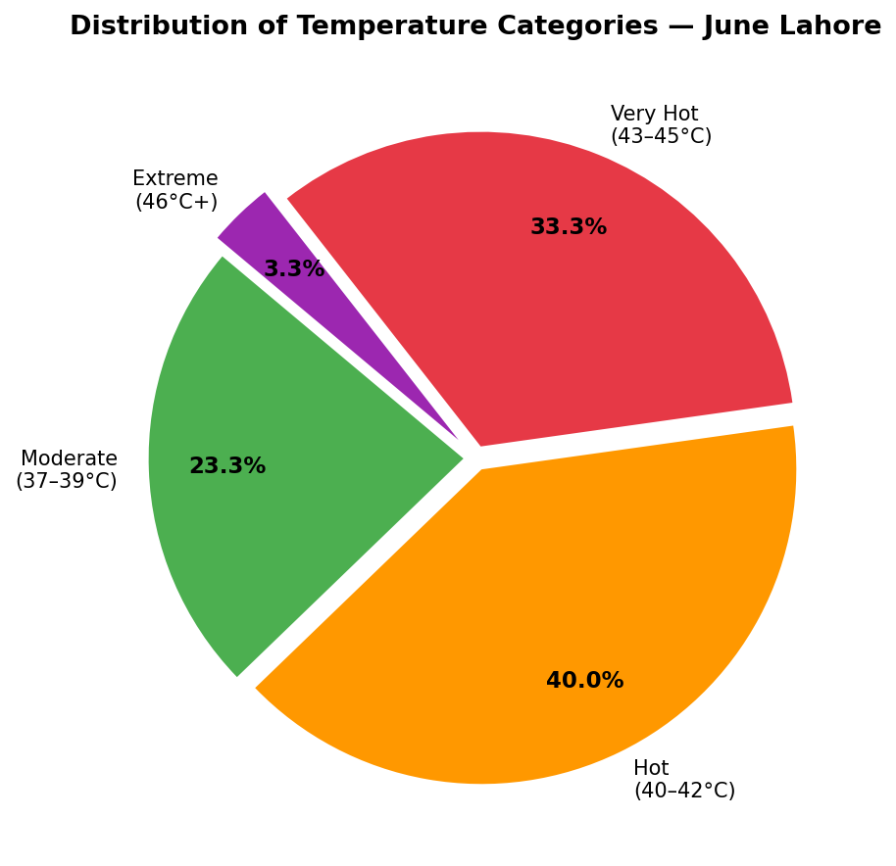
Figure 4: Proportion of Days by Temperature Category
Interpretation: The majority of June days (over 56%) fell in the Very Hot (43–45°C) category. Only a small proportion were in the moderate range, confirming that Lahore experiences severe summer heat throughout the month.

4. Chapter 3: Measures of Central Tendency
Measures of central tendency tell us about the center (typical value) of the data.
4.1 Mean (Arithmetic Average)
Sample Mean | x̄ = Σx / n = (38+40+39+...+38) / 30 = 1243 / 30 = 41.43°C

Result: x̄ = 41.4333°C
Interpretation: On average, the daily maximum temperature in Lahore during June 2024 was 41.43°C. This is well above the comfortable range and indicates consistently hot conditions throughout the month.
4.2 Median
Median | Sort data → n=30 (even) → Median = (15th + 16th value) / 2 = (41 + 42) / 2 = 41.5°C

Result: Median = 41.5°C
Interpretation: Half of the days had temperatures at or below 41.5°C. The median is very close to the mean, which suggests the data is approximately symmetric (not heavily skewed).
4.3 Mode
Mode | Most frequently occurring value in: {38,39,40,41,42,43,44,45,46,...} → Mode = 43°C

Result: Mode = 43°C
Interpretation: 43°C was the most commonly recorded temperature in June, appearing 4 times. This confirms that very hot days were the norm rather than the exception.
4.4 Comparison of Central Tendency Measures
Measure | Value | What it means
Mean | 41.4333°C | Average daily max temperature
Median | 41.5°C | Middle value — 50% of days above & below
Mode | 43°C | Most common temperature

Since Mean ≈ Median ≈ Mode, the temperature distribution is approximately symmetric — consistent with a normal distribution.

5. Chapter 3: Measures of Variation & Spread
Measures of variation tell us how spread out the temperature values are from the mean.
5.1 Range
Range | = Max - Min = 46 - 37 = 9°C

Interpretation: The range of 9°C shows that temperatures varied by 9 degrees across the month. While this gives a basic idea of spread, it only considers extreme values and ignores how data is distributed in between.
5.2 Sample Variance
Variance | s² = Σ(x - x̄)² / (n-1)

Step 1: Compute each (x - x̄)², e.g., (38 - 41.43)² = 11.7649, (40 - 41.43)² = 2.0449, etc.
Step 2: Sum all squared deviations = Σ(x - x̄)² = 161.3676
Step 3: s² = 161.3676 / (30-1) = 161.3676 / 29 = 5.5644
Result: s² = 5.5644 °C²
Note: We divide by (n-1) = 29 instead of n = 30 because this is a sample, and dividing by (n-1) gives an unbiased estimate of the true population variance.
5.3 Standard Deviation
Std Dev | s = √s² = √5.5644 = 2.3589°C

Result: s = 2.3589°C
Interpretation: On average, daily temperatures deviated from the mean by ±2.3589°C. This relatively small standard deviation (compared to the mean of 41.43°C) confirms that temperatures were fairly consistent throughout the month, without extreme random swings.
5.4 Coefficient of Variation (CV)
CV | = (s / x̄) × 100% = (2.3589 / 41.4333) × 100% = 5.69%

Interpretation: A CV of 5.69% indicates very low relative variability. This means temperatures were highly consistent relative to their average — Lahore's June is predictably hot every day.

6. Chapter 3: Z-Scores, Quartiles & Outlier Detection
6.1 Z-Scores for Extreme Days
A z-score tells us how many standard deviations a value is from the mean. We calculate z-scores for the hottest and coolest days.
z-score | z = (x - x̄) / s

z-score for the Hottest Day (45°C):
z(45°C) | z = (45 - 41.4333) / 2.3589 = 1.512

Interpretation: A temperature of 45°C is 1.512 standard deviations above the mean. This is an unusually hot day but not extreme enough to be a statistical outlier.
z-score for the Coolest Day (37°C):
z(37°C) | z = (37 - 41.4333) / 2.3589 = -1.8794

Interpretation: A temperature of 37°C is 1.8794 standard deviations below the mean. This is a relatively cooler day for June in Lahore, but still within normal range.
6.2 Five-Number Summary & Quartiles
The five-number summary divides data into four equal parts:
Statistic | Value | Meaning
Minimum | 37°C | Coolest day in June
Q1 (25th percentile) | 40°C | 25% of days were cooler than this
Median / Q2 | 41.5°C | Middle temperature — 50th percentile
Q3 (75th percentile) | 43°C | 75% of days were cooler than this
Maximum | 46°C | Hottest day in June

IQR | = Q3 - Q1 = 43 - 40 = 3°C

Interpretation: The middle 50% of June days had temperatures between 40°C and 43°C. The IQR of 3°C shows the spread of the central half of the data.
6.3 Outlier Detection
Lower Fence | = Q1 - 1.5 × IQR = 40 - 1.5 × 3 = 35.5°C

Upper Fence | = Q3 + 1.5 × IQR = 43 + 1.5 × 3 = 47.5°C

Any value below 35.5°C or above 47.5°C would be considered an outlier. Since all our temperatures are between 37°C and 46°C, there are NO outliers in this dataset. All temperatures fall within the expected range for June in Lahore.
6.4 Box Plot
The box plot below visually summarizes the five-number summary and confirms there are no outliers:
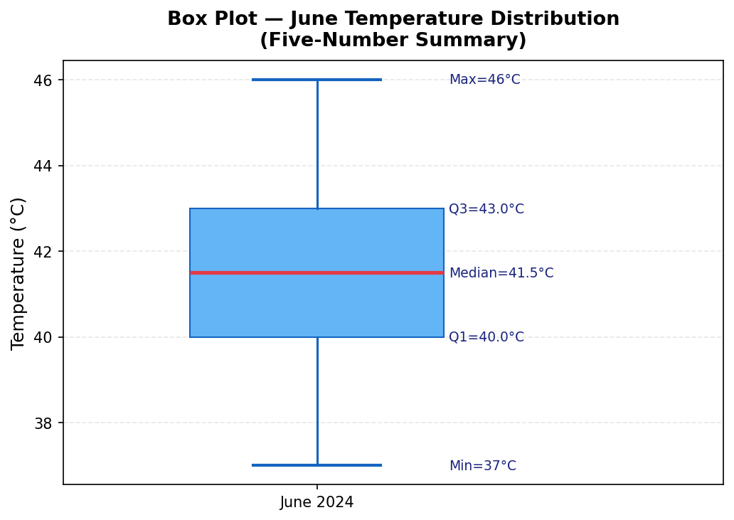
Figure 5: Box Plot Showing Five-Number Summary of June Temperatures

7. Chapter 5: Probability Analysis
Probability allows us to quantify the likelihood of specific weather events occurring. We apply both the classical (relative frequency) approach and the normal distribution approach.
7.1 Classical Probability (Relative Frequency Approach)
Using our 30-day sample data:
P(E) | = Number of favorable outcomes / Total outcomes = f / n

Event | Calculation | Probability | Interpretation
P(Temperature > 40°C) | 19 days out of 30 | 0.6333 | About 63% chance of a day exceeding 40°C
P(Temperature ≤ 40°C) | 11 days out of 30 | 0.3667 | Complement rule: 1 - P(T>40)
P(40°C ≤ T ≤ 43°C) | 17 days out of 30 | 0.5667 | Most common comfortable-hot range
P(Temperature ≥ 45°C) | 3 days out of 30 | 0.1000 | Probability of extreme heat day

7.2 Complement Rule Application
Complement | P(not A) = 1 - P(A)

P(Temperature NOT exceeding 40°C) = 1 - 0.6333 = 0.3667
Real-life meaning: There is only a 36.7% chance that a day in June Lahore stays at or below 40°C. This is critically important for city planners and health authorities who must plan for extreme heat.
7.3 Addition Rule
Event A = Temperature > 43°C, Event B = Temperature > 40°C
Addition Rule | P(A or B) = P(A) + P(B) - P(A and B)

Since A ⊂ B (every day above 43°C is also above 40°C): P(A and B) = P(A) = 0.2000
P(A or B) = 0.2000 + 0.6333 - 0.2000 = 0.6333

8. Chapter 8: Normal Distribution
Since our data has Mean ≈ Median ≈ Mode and a symmetric distribution, we can model the June temperatures using the Normal Distribution. This allows us to calculate more precise probabilities.
8.1 Parameters of the Normal Model
Parameter | Symbol | Value
Population Mean | μ | 41.4333°C
Population Std Dev | σ | 2.3589°C
Distribution | X ~ | N(41.4333, 2.3589²)

8.2 The Empirical Rule (68-95-99.7 Rule)
For a normal distribution N(41.43, 2.36):
Range | Interval | % of Days | Day Count
μ ± 1σ | 39.07°C to 43.79°C | ≈ 68.26% | ≈ 20 days
μ ± 2σ | 36.72°C to 46.15°C | ≈ 95.44% | ≈ 29 days
μ ± 3σ | 34.36°C to 48.51°C | ≈ 99.74% | ≈ 30 days

Real-life interpretation: About 68% of June days had temperatures between 39.07°C and 43.79°C. Almost all days (99.74%) stayed within the range 34.35°C to 48.51°C, which matches actual June weather patterns in Lahore.
8.3 Standard Normal Probabilities (using z-scores)
Standardize | z = (x - μ) / σ

Probability of temperature exceeding 40°C:
z = (40 - 41.4333) / 2.3589 = -0.6076
P(T > 40) = P(Z > -0.6076) = 1 - P(Z < -0.6076) = 0.7283
Probability of temperature exceeding 45°C (extreme heat warning):
z = (45 - 41.4333) / 2.3589 = 1.512
P(T > 45) = P(Z > 1.512) = 1 - P(Z < 1.512) = 0.0653
Real-life implication: There is a 6.53% probability that any given June day in Lahore will exceed 45°C — a dangerous temperature threshold that triggers health alerts and water shortages.
8.4 Normal Distribution Graph
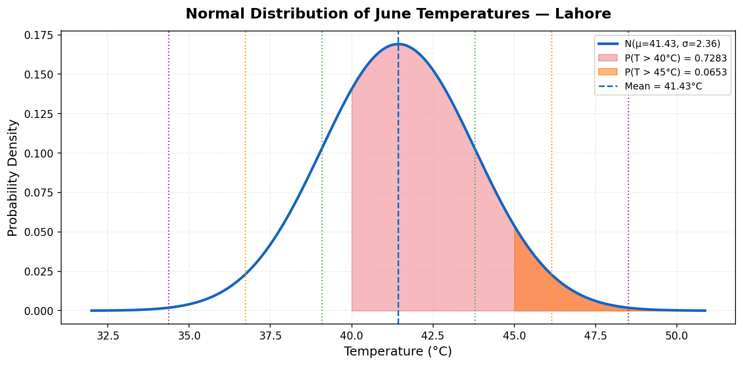
Figure 6: Normal Distribution Curve with Shaded Probability Regions
The graph shows the fitted normal distribution N(41.43, 2.36²). The red shaded area represents P(T > 40°C) and the orange area shows P(T > 45°C). The dotted vertical lines mark the empirical rule boundaries (±1σ, ±2σ, ±3σ).

9. Chapter 8: Confidence Interval for the Mean Temperature
Our sample of 30 days gives us an estimate of the mean temperature. However, different samples would give slightly different means. A confidence interval (CI) gives a range where we are highly confident the true population mean lies.
9.1 Conditions Check
- ✓ Random sample: 30 days selected from June 2024
- ✓ Sample size n = 30 ≥ 30 → Central Limit Theorem applies
- ✓ σ is estimated using sample standard deviation s = 2.3589°C
- ✓ We use a Z-interval (since n ≥ 30, CLT makes the distribution approximately normal)

9.2 95% Confidence Interval Calculation
Z-Interval | CI = x̄ ± z* × (s / √n)

Given: x̄ = 41.4333°C, s = 2.3589°C, n = 30, Confidence Level = 95%
Step 1: Critical value z* = 1.96 (for 95% confidence)
Step 2: Standard Error = s / √n = 2.3589 / √30 = 2.3589 / 5.4772 = 0.4307°C
Step 3: Margin of Error (E) = z* × SE = 1.96 × 0.4307 = 0.8442°C
Step 4: Lower Limit = x̄ - E = 41.4333 - 0.8442 = 40.5892°C
Step 5: Upper Limit = x̄ + E = 41.4333 + 0.8442 = 42.2775°C
95% Confidence Interval: (40.5892°C , 42.2775°C)
Margin of Error = ±0.8442°C

Interpretation: We are 95% confident that the true mean daily maximum temperature in Lahore during June lies between 40.5892°C and 42.2775°C. This narrow interval (width = 1.6883°C) reflects that our sample of 30 days gives a very precise estimate of the true June average temperature.
9.3 Effect of Changing Confidence Level
Confidence Level | z* | Margin of Error | CI Width | Interpretation
90% | 1.645 | ±0.7085°C | 1.4170°C | Narrower — less confident
95% | 1.96 | ±0.8442°C | 1.6883°C | Balanced — standard choice
99% | 2.576 | ±1.1095°C | 2.2190°C | Wider — more confident

Key insight: Higher confidence → wider interval. To be more certain we capture the true mean, we must accept a wider range.

10. Summary of All Statistical Results
Statistical Measure | Formula Used | Result | Chapter
Sample Size (n) | Count | 30 days | Ch 2
Mean (x̄) | Σx / n | 41.4333°C | Ch 3
Median | Middle value (sorted) | 41.5°C | Ch 3
Mode | Most frequent value | 43°C | Ch 3
Range | Max - Min | 9°C | Ch 3
Sample Variance (s²) | Σ(x-x̄)² / (n-1) | 5.5644 °C² | Ch 3
Standard Deviation (s) | √s² | 2.3589°C | Ch 3
Coefficient of Variation | (s/x̄) × 100% | 5.69% | Ch 3
Q1 | 25th Percentile | 40°C | Ch 3
Q3 | 75th Percentile | 43°C | Ch 3
IQR | Q3 - Q1 | 3°C | Ch 3
Lower Outlier Fence | Q1 - 1.5×IQR | 35.5°C | Ch 3
Upper Outlier Fence | Q3 + 1.5×IQR | 47.5°C | Ch 3
Outliers Detected | — | None | Ch 3
z(45°C) — hottest day | (45 - x̄)/s | 1.512 | Ch 3
z(37°C) — coolest day | (37 - x̄)/s | -1.8794 | Ch 3
P(T > 40°C) — sample | f/n | 0.6333 | Ch 5
P(T > 40°C) — normal | 1 - Φ(z) | 0.7283 | Ch 8
P(T > 45°C) — normal | 1 - Φ(z) | 0.0653 | Ch 8
Standard Error | s/√n | 0.4307°C | Ch 8
95% CI — Lower | x̄ - z*×SE | 40.5892°C | Ch 8
95% CI — Upper | x̄ + z*×SE | 42.2775°C | Ch 8

11. Conclusion
This statistical project analyzed the daily maximum temperatures for Lahore during June 2024 using a comprehensive set of statistical and probabilistic tools from the course syllabus. The following key findings emerged:
- The average (mean) daily temperature was 41.4333°C, with a median of 41.5°C and mode of 43°C — all three measures being very close, confirming an approximately symmetric distribution.
- The standard deviation of 2.3589°C and coefficient of variation of 5.69% indicate that temperatures were highly consistent and predictable throughout the month — Lahore's June is reliably extreme.
- No statistical outliers were detected (all values within 35.5°C–47.5°C), meaning even the hottest days (46°C) are within the expected statistical range for this city in this season.
- Using the Normal Distribution, there is a 72.83% probability that a randomly selected June day exceeds 40°C, and a 6.53% probability of exceeding the 45°C danger threshold.
- The 95% Confidence Interval (40.5892°C, 42.2775°C) gives us strong statistical confidence about the true average June temperature in Lahore, with a very narrow margin of error due to our adequate sample size.

Real-Life Implications:
- City authorities can use this data to schedule load-shedding plans and water supply distribution
- Health departments can calculate the probability of heatstroke-risk days and issue preventive advisories
- Schools and outdoor organizations can use the confidence interval to plan safe outdoor activities
- Agricultural planners can assess irrigation needs based on expected temperature ranges

This project demonstrates that statistics is not merely an academic subject — it is a powerful, practical tool that enables us to understand our environment, make predictions, and take informed decisions in daily life. Through frequency distributions, descriptive measures, probability theory, and confidence intervals, we transformed raw temperature numbers into meaningful, actionable knowledge.

